CMSC 495 User Guide
AI Study & Productivity Assistant
Course: CMSC 495 – Capstone Project
Project Team Members:
Victor Rosario
Akshay Sonilal-Rambarran
Jorge Armijosmurillo
Date: February 21, 2026

Contents
1. Introduction 4
2. System Overview 4
3. System Requirements 5
Required Software 5
Supported Operating Systems 5
4. Installation and Setup 5
5. Launching the Application (Windows Users) 6
Step 1: Locate the Project Folder 6
Step 2: Run the Startup Script 6
Step 3: Open the Application in Browser 7
6. Getting Started 8
6.1 Creating an Account 8
6.2 Logging In 10
6.3 Dashboard Overview 11
6.4 Managing Assignments 12
6.5 Generating AI Study Plans 14
6.6 Generating AI Summaries 16
6.7 Viewing Progress 17
6.8 Logging Out 18
7. Standards & Usage Guidelines 18
8. Troubleshooting 18
9. Frequently Asked Questions 19
10. Support & Contact Information 20

1. Introduction
The AI Study & Productivity Assistant is a web-based academic management application designed to help college students organize coursework, manage deadlines, track progress, and receive AI-powered academic assistance.
The system combines:
- Secure user authentication
- Assignment management tools
- Progress analytics
- AI-generated study plans
- AI-generated summaries
This User Guide provides step-by-step instructions for installing, launching, and using the application effectively.

2. System Overview
The AI Study & Productivity Assistant is built using:
- Python (Flask framework)
- SQLAlchemy (database ORM)
- SQLite (local database)
- Hugging Face AI API (optional AI integration)
- HTML/CSS/JavaScript frontend
The system operates locally on the user’s computer and runs through a web browser at:

http://127.0.0.1:5000

All user data is securely stored in a local database file.

3. System Requirements
Before running the application, ensure the following requirements are met:

Required Software
- Python 3.9 or higher
- Git (to clone repository)
- Internet connection (for AI features)
- Modern web browser (Chrome, Firefox, Edge)

Supported Operating Systems
- Windows 10 or later
- macOS
- Linux

4. Installation and Setup
Step 1: Clone the Repository
Open Command Prompt or Git Bash and enter:
git clone https://github.com/Vros15/ai-study-productivity-assistant.git
cd ai-study-productivity-assistant

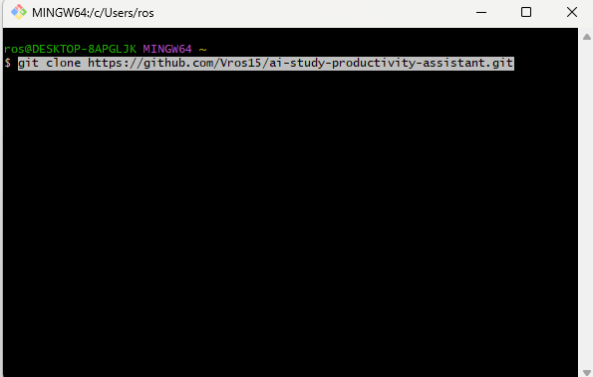
This downloads the application to your computer.

5. Launching the Application (Windows Users)
The project includes an automated startup script to simplify setup.

Step 1: Locate the Project Folder
Open the folder where the repository was cloned.

Step 2: Run the Startup Script
Double-click:
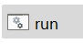
run.bat
cd ai-study-productivity-assistant

The script will automatically:
- Create a virtual environment (if not already created)
- Install required dependencies
- Create a .env file if missing
- Initialize the database
- Launch the Flask server
Figure 1 – Application Startup Screen
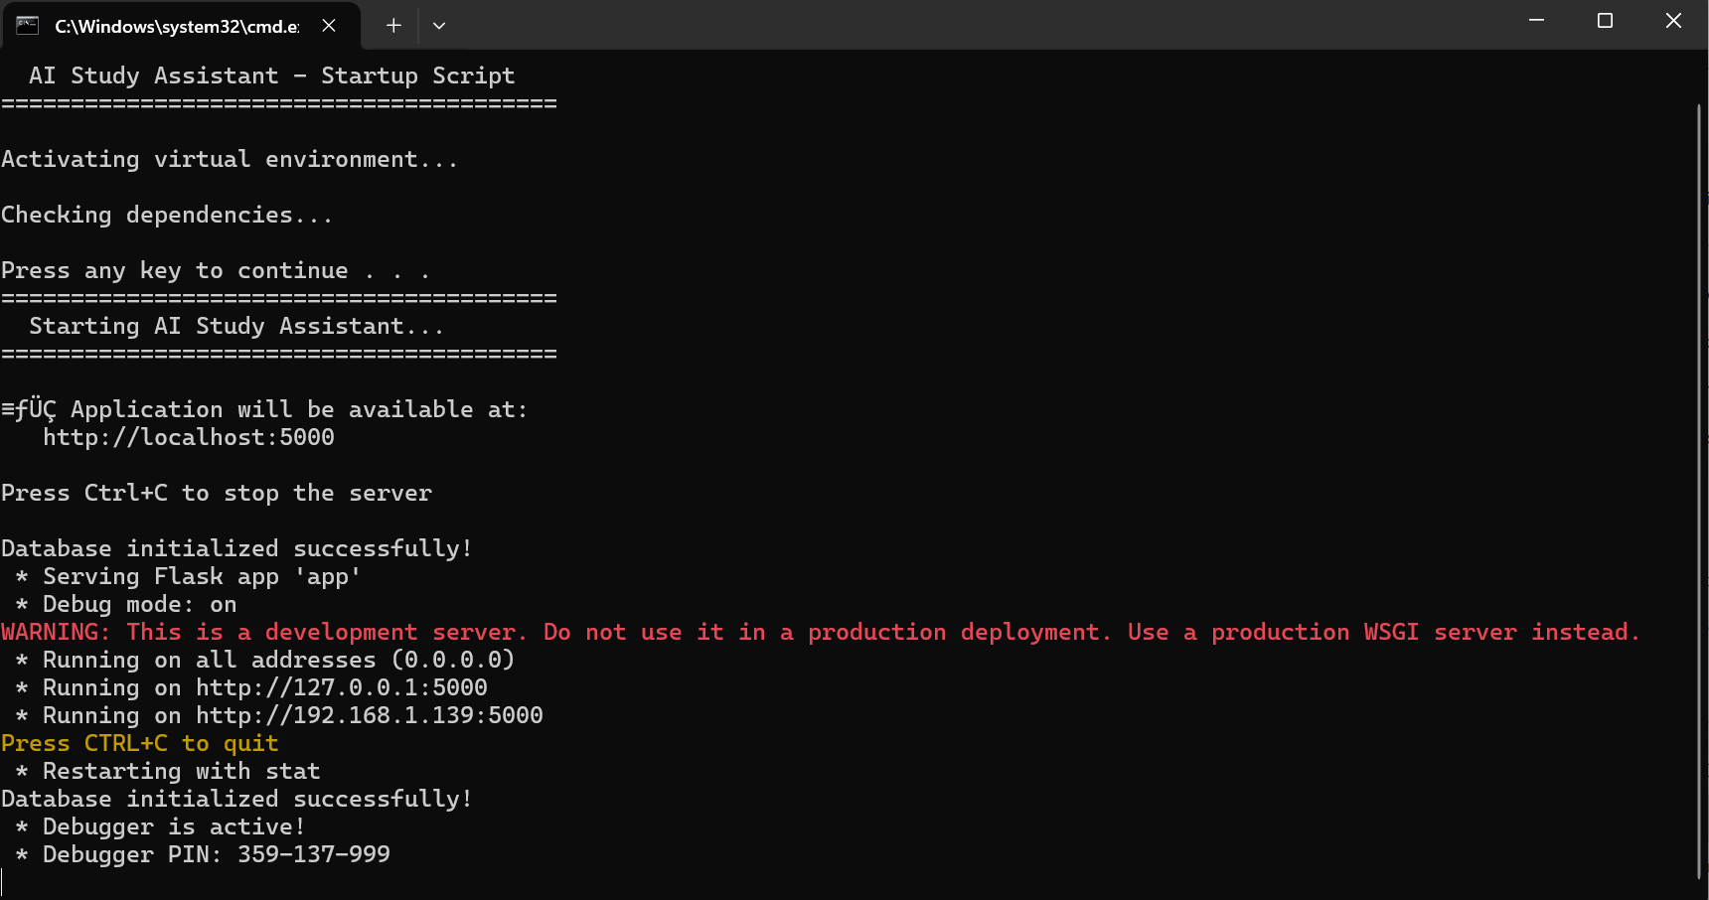
When the application starts successfully, you will see:
Running on http://127.0.0.1:5000
cd ai-study-productivity-assistant

Step 3: Open the Application in Browser
Open your browser and go to:
http://127.0.0.1:5000
cd ai-study-productivity-assistant

Figure 2 – AI Study Assistant Home Page
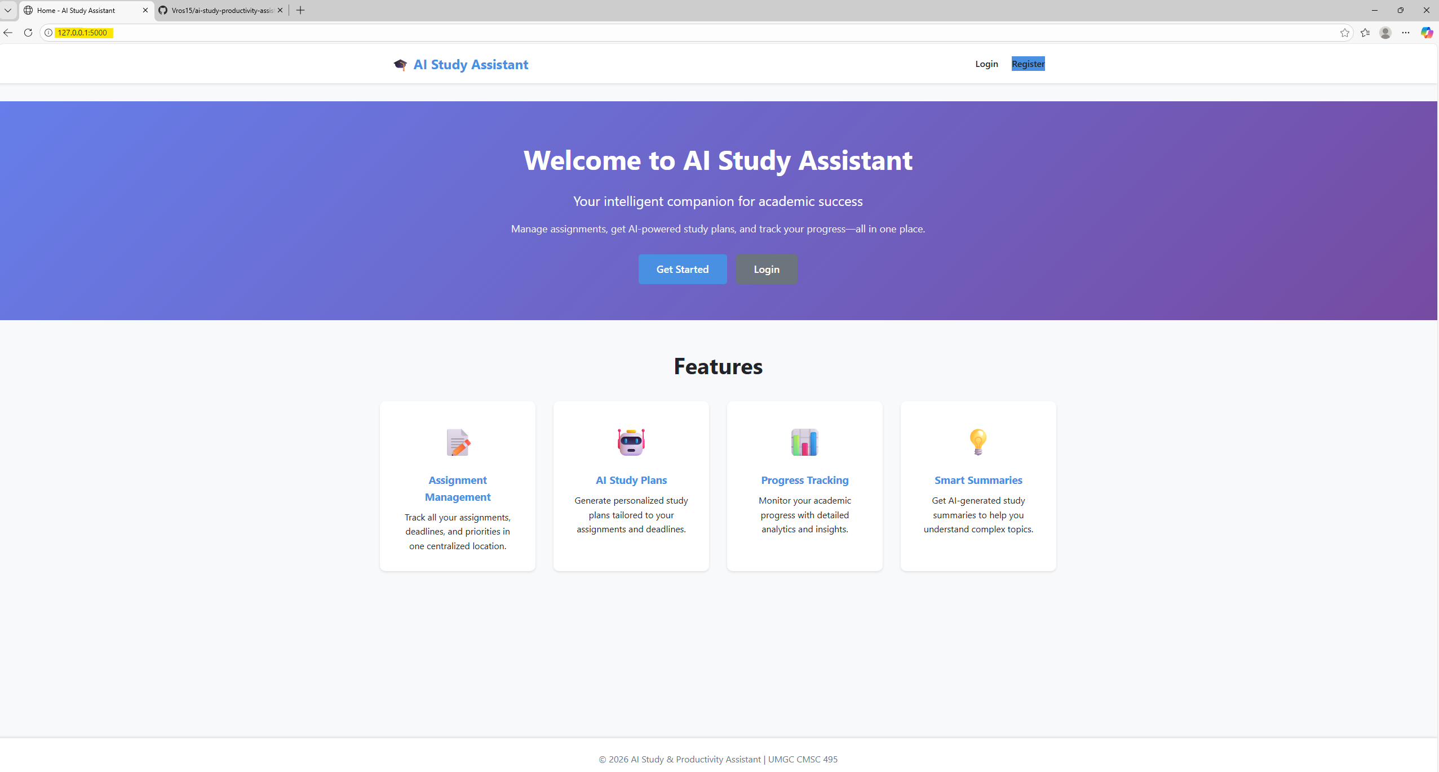

6. Getting Started

6.1 Creating an Account
- Click Register
- Enter:
  - Username
  - Email address
  - Password (minimum 6 characters)
- Click Create Account
If registration is successful, you will be redirected to the login page.
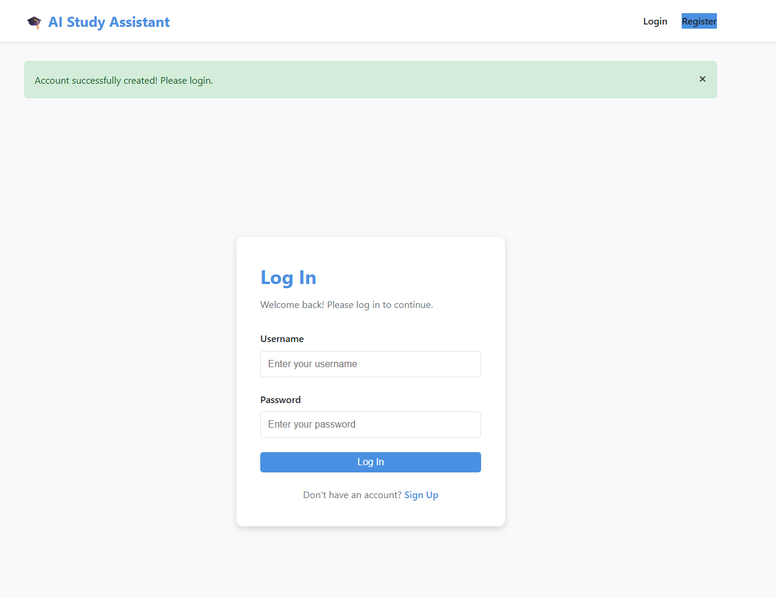

6.2 Logging In
- Enter your username and password.
- Click Log In.
- Upon successful authentication, you will be redirected to your dashboard.
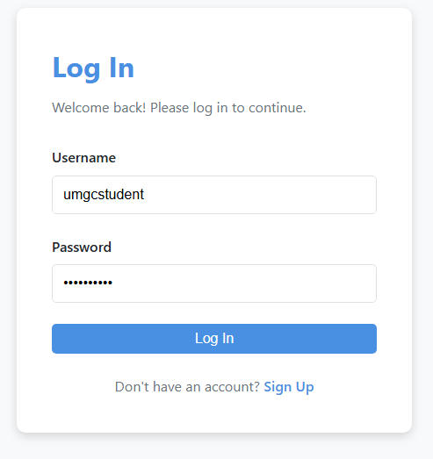
If credentials are incorrect, an error message will appear.

6.3 Dashboard Overview
The Dashboard displays:
- Total assignments
- Completed assignments
- Pending assignments
- Overdue assignments
- Assignment list with:
  - Title
  - Due date
  - Priority
  - Status
  - Action buttons (Edit, Complete, Delete)
Each user can only view their own assignments.
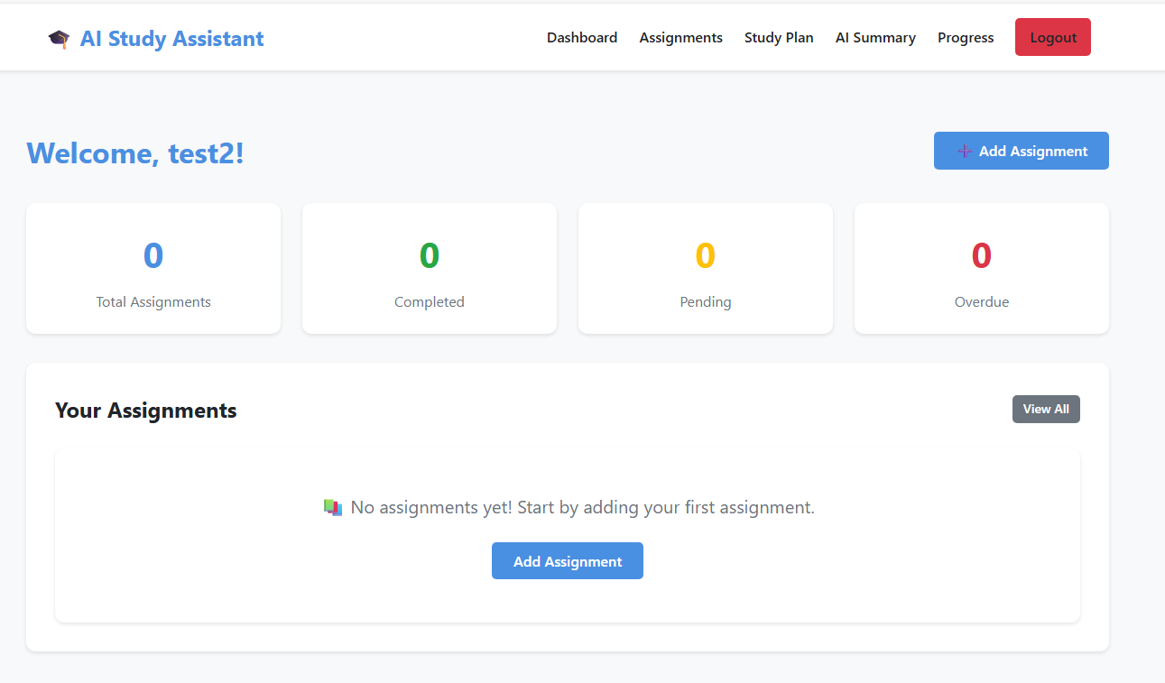

6.4 Managing Assignments
Adding an Assignment
- Click Add Assignment
- Enter:
  - Title
  - Description (optional)
  - Due Date
  - Priority (Low, Medium, High)
- Click Submit
The assignment will appear immediately on your dashboard.
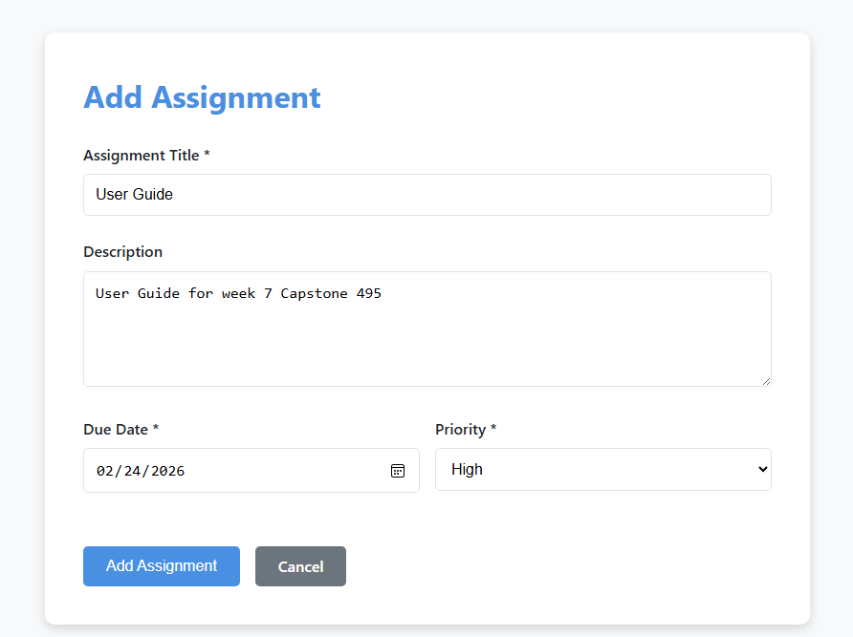
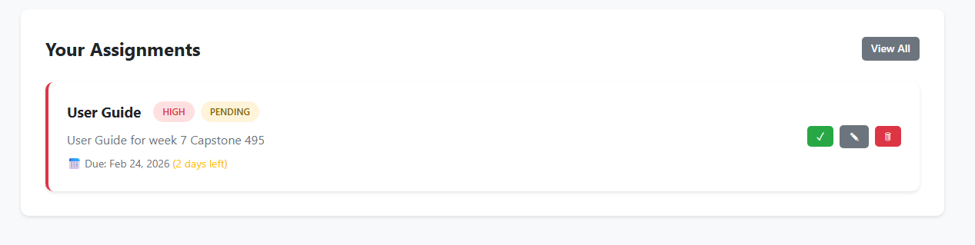

Editing an Assignment
- Click the Edit icon next to an assignment.
- Modify fields as needed.
- Click Save Changes.

Marking an Assignment Complete
Click the Complete (✓) button.
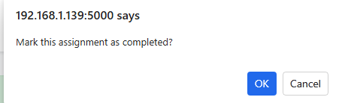
The assignment status updates to Completed.
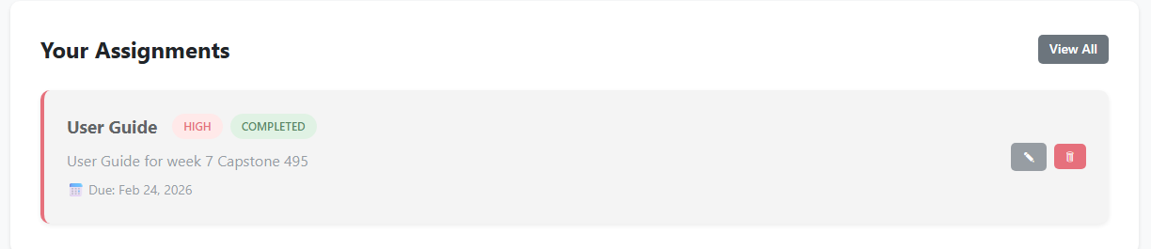
Deleting an Assignment
- Click Delete
- Confirm the action
The assignment is permanently removed from your account.

6.5 Generating AI Study Plans
- Click Study Plan in the navigation menu.
- Select one or more pending assignments.
- Click Generate Study Plan.
The system:
- Sends selected assignments to the AI module.
- Generates a personalized study schedule.
- Displays recommended time allocation and strategies.
- Saves the study plan to your progress history.
If no API key is configured, the system uses a fallback generator.
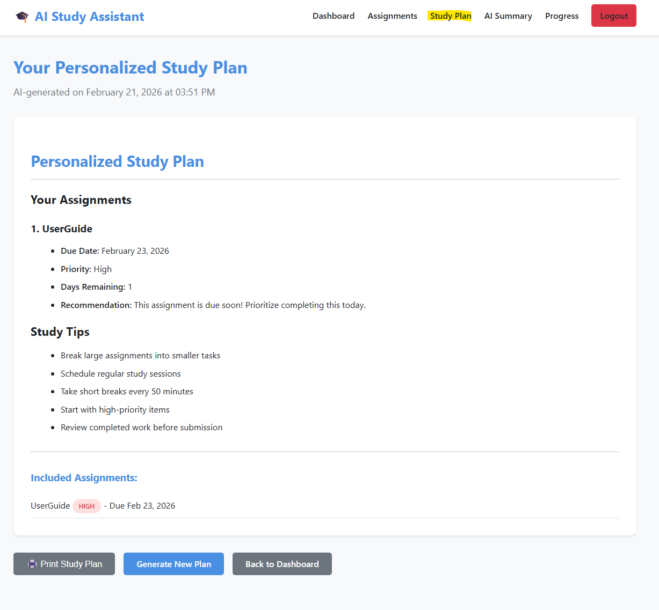

6.6 Generating AI Summaries
- Click AI Summary
- Select an assignment OR enter custom notes.
- Click Generate Summary
The AI module will:
- Analyze the content
- Generate structured study guidance
- Provide key points and recommendations
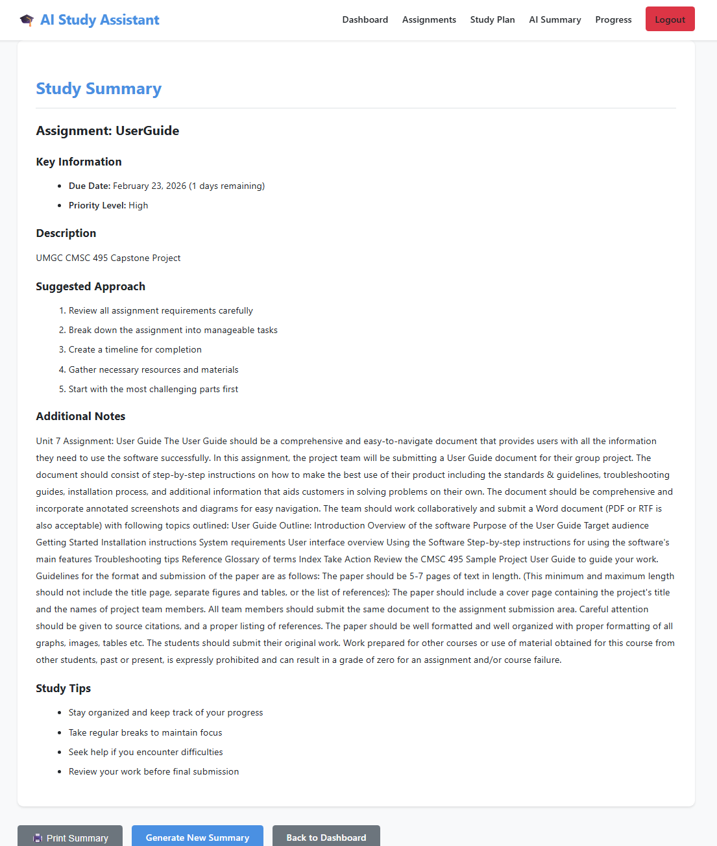

6.7 Viewing Progress
Click Progress to view:
- Completion rate percentage
- Priority breakdown
- Timeline view of assignments
- Recently generated study plans
This feature provides academic performance insights.

6.8 Logging Out
- Click Logout in the top navigation.
- Your session ends securely.
- You are redirected to the home page.

7. Standards & Usage Guidelines
- Use strong passwords.
- Do not share login credentials.
- Keep API keys private in the .env file.
- Do not manually edit the database file.
- Always log out when using shared computers.
- Use the run.bat file to ensure correct startup configuration.

8. Troubleshooting
Application Will Not Start
- Ensure Python is installed.
- Confirm run.bat was executed from project root folder.
- Verify internet connection.
Cannot Access http://127.0.0.1:5000
- Confirm the terminal shows:
Running on http://127.0.0.1:5000
cd ai-study-productivity-assistant

- Refresh the browser.
- Restart the application.
AI Features Not Working
- Verify API key is added to .env.
- Ensure internet connection.
- Restart the application.
Database Errors
- Delete the SQLite database file (development use only).
- Restart the application to reinitialize.

9. Frequently Asked Questions
Q: Can multiple users use the system?
Yes. Each user has separate account data stored securely.
Q: Is my data secure?
Yes. User authentication and session management protect user data.
Q: Does the AI feature require internet?
Yes. AI generation requires internet access.
Q: Can this be deployed publicly?
Yes, with production configuration (WSGI server required).

10. Support & Contact Information
For technical issues:
- Contact project team members
- Submit an issue on GitHub
- Review README documentation

